Christ Church United Methodist

Connect with us online at

[www.ccumtucson.org](http://www.ccumtucson.org) [www.facebook/CCUM.Tucson](http://www.facebook/CCUM.Tucson)

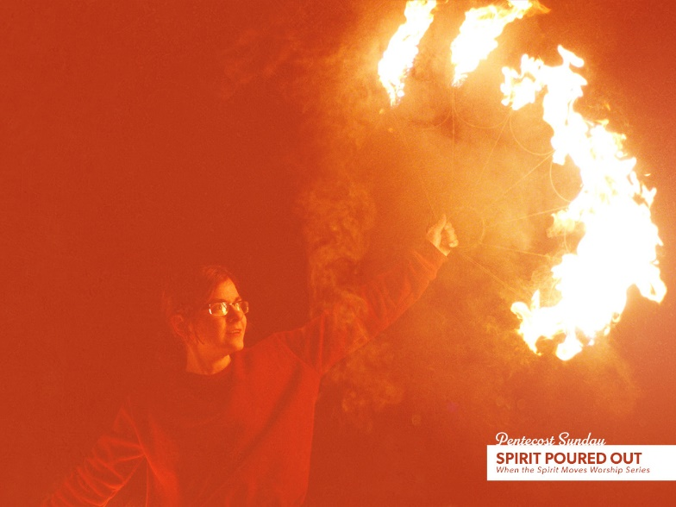

Pentecost, May 19th, 2024

Welcome and Announcements

*\*Please stand*

Recognition of Graduates

Trinity Chimes

**Prelude** *He's Got the Whole World in His Hands*

arr. Joe Utterback

*Call to Worship

One: Fire, wind, dove, earthquake, stillness in the storm:

All: Spirit of the living God, fall afresh on us!

One: Burn and blow away our fears, alight on us with gentle hope,

All: Shake the foundations of the world, hold us in the quiet center,

One: Spirit of the living God, renew us once more

All: We are here and wait with expectation, Spirit, flow!

**\*Hymn of Praise** 539 *O Spirit of the Living God* FOREST GREEN

1. O Spirit of the living God, thou light and fire divine,

descend upon thy church once more, and make it truly thine.

Fill it with love and joy and power, with righteousness and peace;

till Christ shall dwell in human hearts, and sin and sorrow cease.

2. Blow, wind of God! With wisdom blow until our minds are free,

from mists of error, clouds of doubt, which blind our eyes to thee.

Burn, winged fire! Inspire our lips with flaming love and zeal,

to preach to all thy great good news, God’s glorious commonweal!

3.Teach us to utter living words of truth which all may hear,

the language all may understand when love speaks loud and clear;

till every age and race and clime shall blend their creeds in one,

and earth shall form one family by whom thy will is done.

4. So shall we know the power of Christ who came this world to save;so shall we rise with him to life which soars beyond the grave;

and earth shall win true holiness, which makes thy children whole;

till, perfected by thee, we reach creations glorious goal!

**Prayer for Pentecost**

**Holy One, for all of the ways you speak to us – in rushing wind, in dancing flames, in words we understand, and in all that transcends language, we give thanks. Give us courage to speak your love, everywhere we go, to everyone we meet.  
Amen.**

*Written by Joanna Harader, posted on Practicing Families.*

**Responsive Reading** Psalm 104: 24-34, 35b

**24**O Lord, how manifold are your works!  
     **In wisdom you have made them all;  
     the earth is full of your creatures.**  
**25**Yonder is the sea, great and wide;  
     **creeping things innumerable are there,  
     living things both small and great.  
26**There go the ships  
     and Leviathan that you formed to sport in it.

**27These all look to you  
     to give them their food in due season;**  
**28**when you give to them, they gather it up;  
     **when you open your hand, they are filled with**

**good things.**  
**29**When you hide your face, they are dismayed;  
     **when you take away their breath, they die  
     and return to their dust. 30**When you send forth your spirit,[[a](https://www.biblegateway.com/passage/?search=Psalms+104%3A+24-34%2C+35b&version=NRSVUE#fen-NRSVUE-15602a)] they are created,  
**and you renew the face of the ground.**

**31**May the glory of the Lord endure forever;  
     may the Lord rejoice in his works—  
**32who looks on the earth and it trembles,  
     who touches the mountains and they smoke.  
33**I will sing to the Lord as long as I live;  
**I will sing praise to my God while I have being.  
34**May my meditation be pleasing to the Lord,  
     in whom I rejoice.

**35** **Let sinners be consumed from the earth,  
    and let the wicked be no more**!  
 Bless the Lord, O my soul!  
 **Praise the Lord!**

Childrens Moment

*All Children are invited to come up to the front and afterword go to Sunday School*

Music of Preparation *O God Beyond All Praising*

arr. Alejandro D. Consolacion II

The Chancel Choir

Scripture Lesson Acts 2:1-21 (NRSV)

Sermon Being Church: a spirit-filled birthday

**Music of Response** 393 *Spirit of the Living God* LIVING GOD

Spirit of the living God, fall afresh on me.

Spirit of the living God, fall afresh on me.

Melt me, mold me, fill me, use me.

Spirit of the living God, fall afresh on me.

Spirit of the living God, move among us all.

Make us one in heart and mind, make us one in love.

Humble, caring, selfless, sharing.

Spirit of the living God, move among us all.

Prayers of the People

Confession and Pardon

**O God, we have heard your Pentecost story: your Spirit is here, your church is born, and the day of the Lord is coming. In your Spirit, we have new life and hope. Still, O Lord, we cannot trust, for we fear our lives are beyond repair. Still, O Lord, we turn away, for we fear our hope is foolish. Still, O Lord, we create isolation, for we fear one another and act as though we are cut off from your presence. Forgive us, Holy One. As you did for your first church, breathe the fire of life into us. As you do for each generation, reveal to us your life-giving presence.**

*Adapted from work by Rev. Anna George Traynham*

Pastor:  Hear the Good News, Christ is among us renewing us for life with love.  In the name of Christ, you are forgiven!

**People: In the name of Christ you are forgiven!**

**All: Glory to God, Amen.**

The Lord’s Prayer

Our Father, who art in heaven, hallowed be thy name.

Thy kingdom come, thy will be done, on earth as it is in heaven. Give us this day our daily bread and forgive us our trespasses as we forgive those who trespass against us, and lead us not into temptation, but deliver us from evil, for thine is the kingdom, the power, and the glory, forever, Amen.

*Passing of the Peace

Invitation to Offering

**Offertory** *Spirit Medley*  arr. Mark Hayes

*Doxology 94 *Praise God, from Whom all Blessings Flow*

Praise God, from whom all blessings flow;

Praise God, all creatures here below: Alleluia! Alleluia!

Praise God, the source of all our gifts!

Praise Jesus Christ, whose power up lifts!

Praise the Spirit, Holy Spirit!

Alleluia! Alleluia! Alleluia!

*Offertory Prayer

**\*Sending Hymn** 347 *Spirit Song* SPIRIT SONG

1. O let the Son of God enfold you

with his Spirit and his love.

Let him fill your heart and satisfy your soul.

O let him have the things that hold you,

and his Spirit like a dove

will descend upon your life and make you whole.

**Refrain:**

Jesus, O Jesus, come and fill your lambs.

Jesus, O Jesus, come and fill your lambs.

2. O come and sing this song with gladness

as your hearts are filled with joy.

Lift your hands in sweet surrender to his name.

O give him all your tears and sadness,

give him all your years of pain,

and you’ll enter into life in Jesus’ name.

**Refrain**

Benediction

Go into the world that God so loves, ready to be amazed and astonished, for the winds of the Spirit are starting to move.

Let us go knowing that the Spirit goes behind and before us, drawing us into the heart of God, into the presence of our Savior and each other. Amen.

*Adapted from work by Rev. Anna George Traynham*

**Postlude**  *Stand Up for Jesus/Onward Christian Soldiers*

arr. Paul Mickelson

Liturgist: Peggy Bartlett

Stephen Minister: Michael Edwards

Thank you to all of the volunteers and staff who made this service possible!

ONE LICENSE A-738133 | CCLI #12393 | Perform Music #662 | CVLI #03793174

“O Spirit of the Living God”

Words: Henry H Tweedy, 1935 (Acts 2)

“Spirit of the God”

Words: Daniel Iverson, 1926 (Act 11:15)

“Spirit Song”

Words: John Wimber, 1979

If you have any questions, please call the office: 520.327.1116 or

send us an e-mail: [office@ccumtucson.org](mailto:office@ccumtucson.org).

Staff contact information (Only staff with church emails are listed)

John Neve - Bell Choir Director

[john@ccumtucson.org](mailto:john@ccumtucson.org)

Janet Tolman – Organist

janet@ccumtucson.org

Sinamar Respicio – Choir Director

[choir@ccumtucson.org](mailto:choir@ccumtucson.org)

Mary Beth Buttler – Communications

communications@ccumtucson.org

Candi Eppley – Office Administrator

[office@ccumtucson.org](mailto:office@ccumtucson.org)

Rev. Beth Rambikur

[pastor@ccumtucson.org](mailto:pastor@ccumtucson.org)