Large Print
Christ Church United Methodist
Connect with us online at
www.ccumtucson.org www.facebook/CCUM.Tucson

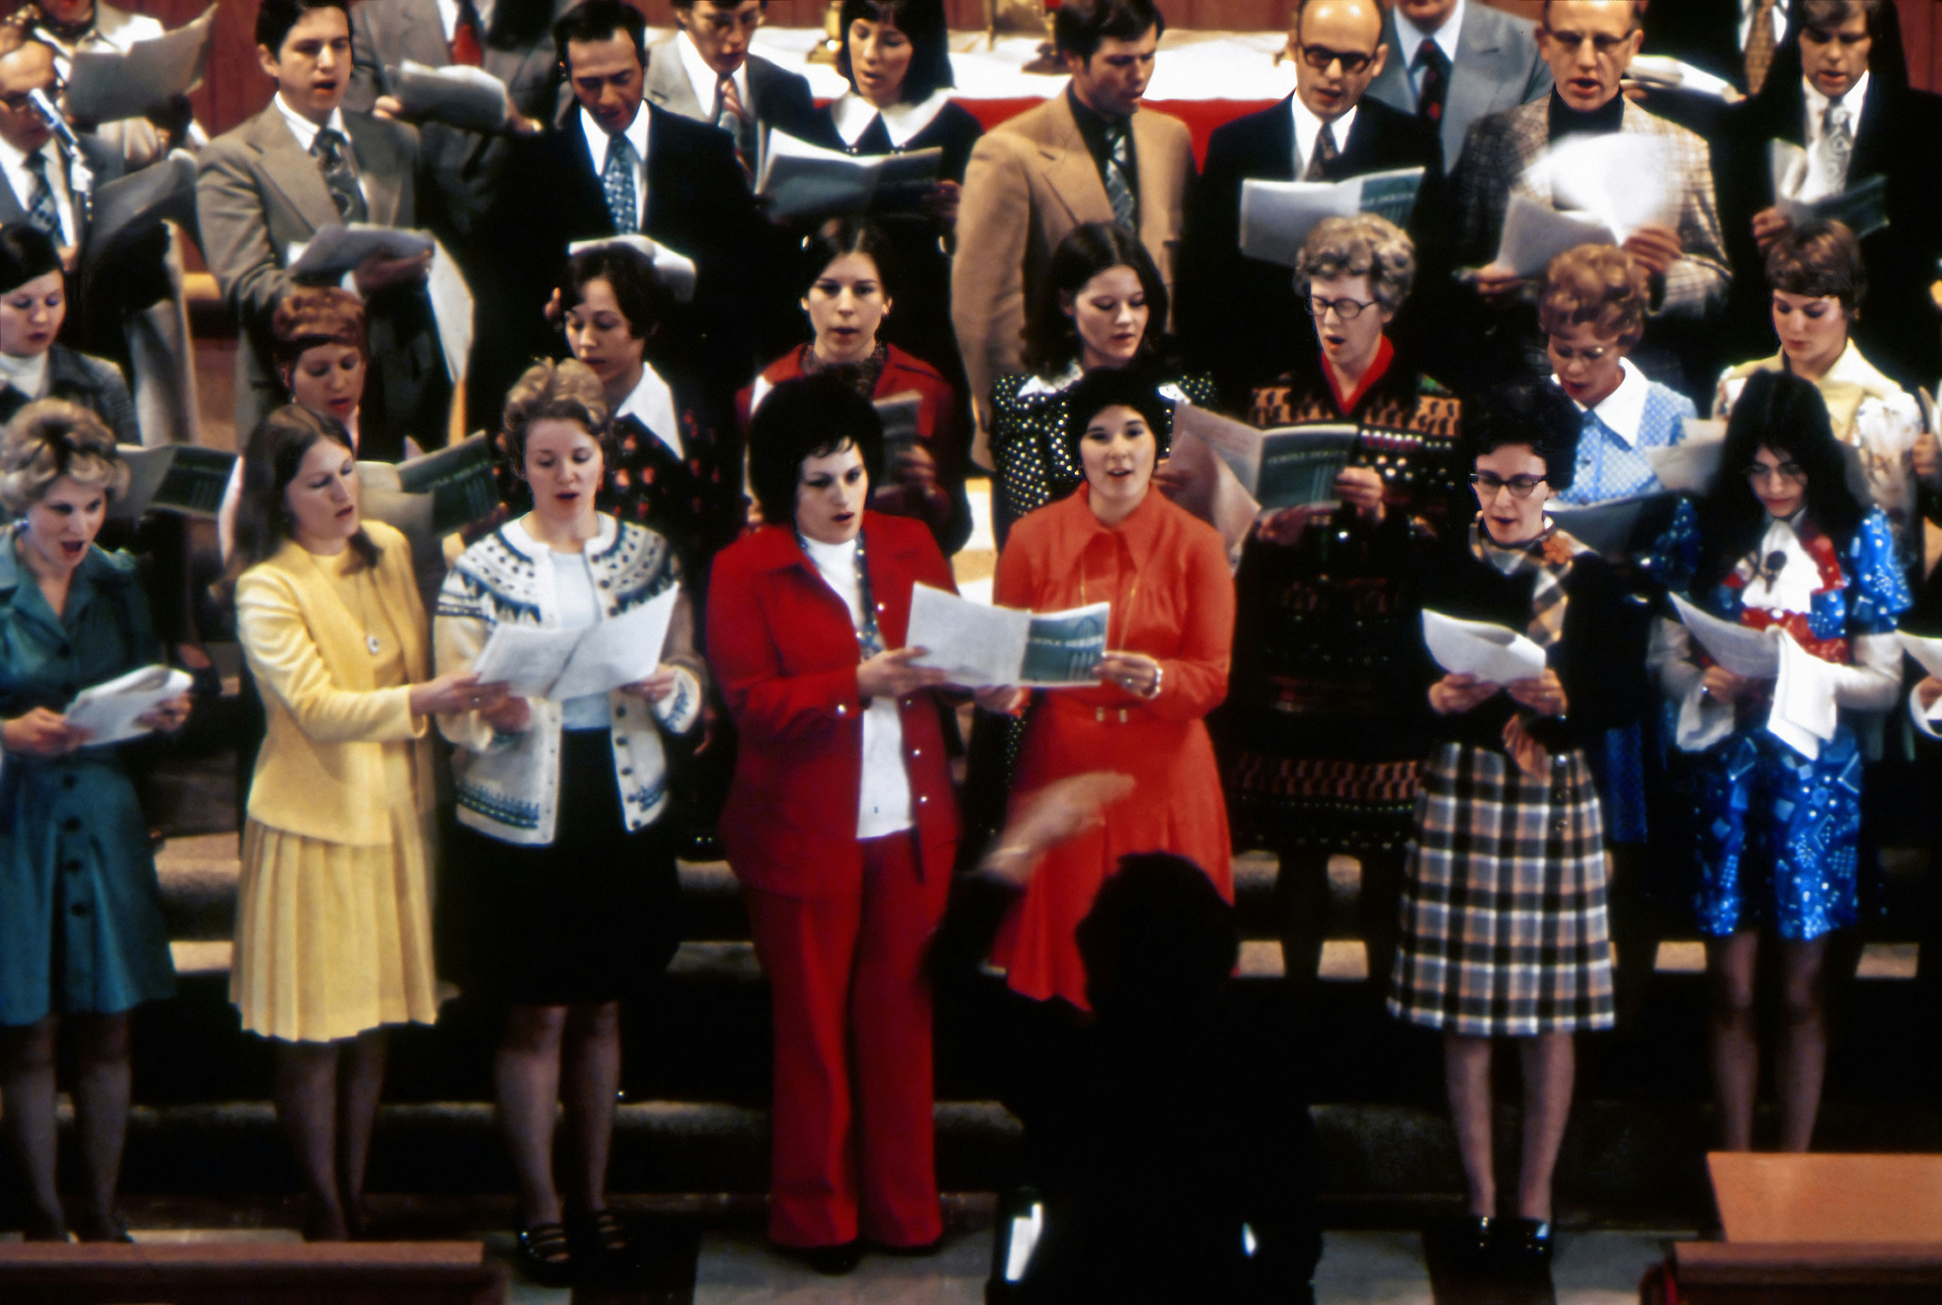
5th Sunday after Pentecost, June 23rd, 2024

Welcome and Announcements

*Please stand

Trinity Chimes

Prelude With God, Nothing Is Impossible
Robert S. Hughes
Kathryn Snodgrass, piano;
Janet Tolman, organ

*Call to Worship

One: Make a joyful noise to the Lord, all the earth.
All: Serve the Lord with gladness; come into his presence with singing.
One: Enter his gates with Thanksgiving and his courts with praise.
All: Give thanks to God, bless the name of the Lord!

*Hymn of Praise 96 Praise the Lord Who Reigns Above AMSTERDAM
- Praise the Lord who reigns above and keeps his court below; praise the holy God of love and all his greatness show; praise him for his noble deeds, praise him for his matchless power; him from whom all good proceeds let earth and heaven adore.
2. Celebrate th'eternal God with harp and psaltery, timbrels soft and cymbals loud in this high praise agree; praise him every tuneful string; all the reach of heavenly
art, all the powers of music bring, the music of the heart.

3. God, in whom they move and live, let every creature sing, glory to their Maker give, and homage to their King. Hallowed be thy name beneath, as in heaven on
earth adored; praise the Lord in every breath, let all things praise the Lord.

Scripture Lesson Psalm 98

O sing to the Lord a new song,

For the Lord has done marvelous things!

God’s right hand and holy arm

have gotten the victory.

The Lord has declared victory,

and has revealed his vindication in the sight of the nations.

The Lord has remembered his steadfast love and faithfulness to the house of Israel.

All the ends of the earth have seen

the victory of our God.

Make a joyful noise to the Lord, all the earth;

break forth into joyous song and sing praise!

Sing praises to the Lord with the lyre,

with the lyre and the sound of melody!

With trumpets and the sound of the horn

make a joyful noise before the Ruler, the Lord!

Let the sea roar, and all that fills it,

the world and those who dwell in it!

Let the floods clap their hands;

let the hills sing for joy together before the Lord,

who comes to judge the earth.

The Lord will judge the world with righteousness,

and the peoples with equity.

Introducing Hymn Sing 145 Morning Has Broken BUNESSAN

1. Morning has broken like the first morning; blackbird has spoken like the first bird. Praise for the singing! Praise for the morning! Praise for them springing fresh from the Word!

2. Sweet the rain's new fall sunlit from heaven, like the first dewfall on the first grass. Praise for the sweetness of the wet garden, sprung in completeness where his feet pass.

3. Mine is the sunlight! Mine is the morning born of the one light Eden saw play! Praise with elation, praise every morning, God's recreation of the new day!

Prayers of the People

Confession and Pardon
Holy God, hear our prayer. There is pain and there is sorrow, there are broken relationships and broken hearts. Sometimes we are the cause of those things. We have caused pain. We have broken the relationship. Sometimes we are simply a part of them – we are the ones who suffer, we are the ones who are broken. So we ask for your forgiveness, and we ask for your healing. Beyond that, we ask that you would help us turn from our former selves to the persons you have created us to be, full of mercy and grace and love. Through Christ, who is our example, we pray. Amen.
Written by Beth Merrill Neel on her blog, “Hold Fast to What Is Good.” Used with permission.
Posted at https://holdfasttowhatisgood.com/liturgy/prayer-of-confession/.

Pastor: Hear the Good News, Christ is among us renewing us for life with love. In the name of Christ, you are forgiven!

People: In the name of Christ you are forgiven!

All: Glory to God, Amen.

Lord’s Prayer

Our Father, who art in heaven, hallowed be thy name.

Thy kingdom come, thy will be done, on earth as it is in heaven. Give us this day our daily bread and forgive us our trespasses as we forgive those who trespass against us, and lead us not into temptation, but deliver us from evil, for thine is the kingdom and the power and the glory forever. Amen.

Open Hymn Sing

*Passing of the Peace

Invitation to Offering

Offertory 'Tis So Sweet to Trust in Jesus arr. Gayden C. Sikes

Kathryn Snodgrass, piano; Janet Tolman, organ

*Doxology 94 Praise God, from Whom all Blessings Flow

Praise God, from whom all blessings flow;

Praise God, all creatures here below: Alleluia! Alleluia!

Praise God, the source of all our gifts!

Praise Jesus Christ, whose power uplifts!

Praise the Spirit, Holy Spirit!

Alleluia! Alleluia! Alleluia!

*Offertory Prayer

*Closing Hymn 380 There's Within My Heart a Melody (1,2,4)
SWEETEST NAME
1. There's within my heart a melody
Jesus whispers sweet and low:
Fear not, I am with thee, peace, be still,
in all of life's ebb and flow.

REFRAIN
Jesus, Jesus, Jesus, sweetest name I know, fills my every longing, keeps me singing as I go.

2. All my life was wrecked by sin and strife, discord filled my heart with pain;
Jesus swept across the broken strings,
stirred the slumbering chords again.

REFRAIN

4. Feasting on the riches of his grace,
resting neath his sheltering wing,
always looking on his smiling face,
that is why I shout and sing.

REFRAIN

*Benediction

May the Lord bless you and keep you. May the Lord make his face shine upon you and be gracious unto you. May the Lord lift up his countenance upon you and give you peace

Postlude God of Our Fathers arr. deCou

Kathryn Snodgrass, piano;

Janet Tolman, organ

Liturgist: Pastor Beth

Stephen Minister: Georgia Carmichael

Thank you to all the staff and volunteers who made this service possible!

ONE LICENSE A-738133 | CCLI #12393 | Perform Music #662 | CVLI #03793174

“Praise the Lord Who Reigns Above”

Words: Charles Wesley, 1743 (Ps.150)

“There’s Within My Heart a Melody”

Words: Luther B Bridgers, 1910

NOTES

