### Large Print

### Christ Church United Methodisthttp://spartafumc.org/clientimages/45879/methodist%20cross.jpg

Connect with us online at

[www.ccumtucson.org](http://www.ccumtucson.org) [www.facebook/CCUM.Tucson](http://www.facebook/CCUM.Tucson)

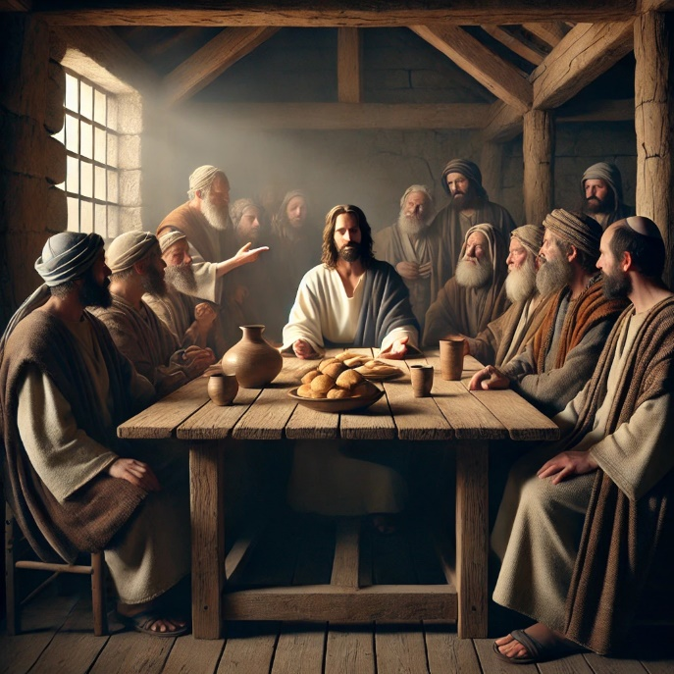

Figure 1OpenAI. (2024). Realistic depiction of Mark 7

15th Sunday after Pentecost, September 1st, 2024

Welcome and Announcements

*\*Please stand*

Trinity Chimes

**Prelude** *Variations on DIX*  Robert F. Swift

*Call to Worship

One: Seek God, not with empty rituals, but with open hearts.

All: Worship, not with empty words, but with lives full of praise.

One: God, you invite our sincerity, our authenticity.

All: Remind us that you call forth our love, our best selves. Amen.

**\*Hymn of Praise** 92 *For the Beauty of the Earth*

DIX

1. For the beauty of the earth,

for the glory of the skies,

for the love which from our birth

over and around us lies;

REFRAIN

Lord of all to thee we raise

this our hymn of grateful praise.

2. For the beauty of each hour

of the day and of the night,

hill and vale, and tree and flower,

sun and moon, and stars of light;

REFRAIN

3. For the joy of ear and eye,

for the heart and mind's delight,

for the mystic harmony

linking sense to sound and sight;

REFRAIN

4. For the joy of human love,

brother, sister, parent, child,

friends on earth and friends above,

for all gentle thoughts and mild;

REFRAIN

5. For thy church, that evermore

lifteth holy hands above,

offering up on every shore

her pure sacrifice of love;

REFRAIN

6. For thyself, best Gift Divine,

to the world so freely given,

for that great, great love of thine,

peace on earth, and joy of heaven.

REFRAIN

Opening Prayer

**Word of Life, open our hearts and minds to the power of Your love and grace at work within us and through others. Remind us that our words and deeds carry weight in this world, and guide us to strive for Your goodness in all we do. Amen.**

Scripture Lesson Song of Solomon 2:8-13

(CEB)

Listen! It’s my lover: here he comes now, **leaping upon the mountains,  
        bounding over the hills.**My lover is like a gazelle  
        or a young stag.  
**Here he stands now,  
        outside our wall,**peering through the windows,  
        peeking through the lattices.

**My lover spoke and said to me,  
“Rise up, my dearest,  
        my fairest, and go.**Here, the winter is past;  
        the rains have come and gone**.  
Blossoms have appeared in the land;  
        the season of singinghas arrived,  
        and the sound of the turtledove is heard in our land.**The green fruit is on the fig tree,  
        and the grapevines in bloom are fragrant. **Rise up, my dearest,  
        my fairest, and go.**

**Music of Preparation** Communion Invitation

Craig Courtney

The Chancel Choir

Gospel Lesson Mark 7:1-8. 14-15. 21-23

CEB

Sermon It is right, and a good and joyful thing Beth Rambikur, Pastor

Musical Response

*The Passing of the Peace

Invitation to Offering

Offertory *Rest* arr. Carl Seal

Tom Messmore, solo

*Doxology 95 *Praise God, from Whom all Blessings Flow*

Praise God, from whom all blessings flow;

Praise God, all creatures here below:

Praise God above, ye heavenly host;

Praise Father, Son, and Holy Ghost. Amen.

*Offertory Prayer

*Communion

The Lord be with you

And Also with you!

Lift up your hearts.

We lift them up to the Lord.

Let us give thanks to the Lord our God.

It is right to give our thanks and praise.

It is right, and a good and joyful thing,

always and everywhere to give thanks to you,

Almighty God, Creator of heaven and earth.

You shaped us from the dust of the earth and breathed life into us, forming humanity in your image.

And so, with your people on earth and all the company of heaven, we praise your name and join their unending hymn:

**Holy, holy, holy Lord, God of power and might, Heaven and earth are full of your glory. Hosanna in the highest. Blessed is he who comes in the name of the Lord. Hosanna in the highest.**

Holy are you, and blessed is your Son Jesus Christ.

By the baptism of his suffering, death, and resurrection

you gave birth to your Church, delivered us from our slavery to sin and death, and made with us a new covenant by water and the Spirit.

On the night in which he gave himself up for us, Jesus took bread, gave thanks to you, broke the bread, gave it to his disciples, and said: "Take, eat; this is my body which is given for you. Do this in remembrance of me."

When the supper was over he took the cup,

gave thanks to you, gave it to his disciples, and said:

"Drink from this, all of you; this is the new covenant,

poured out for you and for all for the forgiveness of sins.

Do this, as often as you drink it, in remembrance of me."

And so, in remembrance of these your mighty acts in Jesus Christ, we offer ourselves in praise and thanksgiving as a holy and living sacrifice, in union with Christ's offering for us, as we proclaim the mystery of faith.

Christ has died; Christ is risen; Christ will come again.

Pour out your Holy Spirit on us gathered together and on these gifts of food and drink. Make them be for us the body and blood of Christ, that we may be for the world the body of Christ, redeemed by his love.

By your Spirit make us one with Christ, one with each other, and one in ministry to all the world until Christ comes in final victory, and we feast at his heavenly banquet.

Through your Son Jesus Christ, with the Holy Spirit in your holy Church, all honor and glory is yours, almighty Father (God), now and forever. Amen!

**\*Communion Hymn** *628 Eat This Bread*

BERTHIER

                  (sing three times)

Eat this bread. drink this cup,

come to me and never be hungry.

Eat this bread, drink this cup,

trust in me and you will not thirst.

Lord’s Prayer

Our Father, who art in heaven, hallowed be thy name.

Thy kingdom come, thy will be done, on earth as it is in heaven. Give us this day our daily bread and forgive us our trespasses as we forgive those who trespass against us, and lead us not into temptation, but deliver us from evil, for thine is the kingdom and the power and the glory forever. Amen.

**\*Closing Hymn** 189 *Fairest Lord Jesus*

ST. ELIZABETH

1. Fairest Lord Jesus, ruler of all nature,

O thou of God and man the Son,

thee will I cherish, thee will I honor,

thou, my soul's glory, joy, and crown.

2. Fair are the meadows, fairer still the woodlands,

robed in the blooming garb of spring:

Jesus is fairer, Jesus is purer,

who makes the woeful heart to sing.

3. Fair is the sunshine, fairer still the moonlight,

and all the twinkling starry host:

Jesus shines brighter, Jesus shines purer,

than all the angels heaven can boast.

4. Beautiful Savior! Lord of all the nations!

Son of God and Son of Man!

Glory and honor, praise, adoration,

now and forevermore be thine.

*Benediction

May the Lord bless you and keep you. May the Lord make his face shine upon you and be gracious unto you. May the Lord lift up his countenance upon you and give you peace

Postlude *Toccata on LEONI*

Gordon Young

Liturgist: Paula Jameson

Stephen Minister: Georgia Carmichael

Golf Cart Driver: Ron Thompson

Thank you to all the staff and volunteers who made this service possible!

ONE LICENSE A-738133 | CCLI #12393 | Perform Music #662 | CVLI #03793174

“For the Beauty of the Earth”

Words: Folliot S Pierpoint, 1864

“Eat This BreadleHelp”

Words: Robert Batastini and the Taize Community, 1982

“Fairest Lord Jesus”

Words: Minister Gesangbuc, 1677; trans. Joseph August Seiss, 1873 (Jn. 6:35)

If you have any questions, please call the office: 520.327.1116 or

send us an e-mail: [office@ccumtucson.org](mailto:office@ccumtucson.org).

Staff contact information (Only staff with church emails are listed)

John Neve - Bell Choir Director

[john@ccumtucson.org](mailto:john@ccumtucson.org)

Janet Tolman – Organist

janet@ccumtucson.org

Sinamar Respicio – Choir Director

[choir@ccumtucson.org](mailto:choir@ccumtucson.org)

Mary Beth Buttler – Communications

communications@ccumtucson.org

Candi Eppley – Office Administrator

[office@ccumtucson.org](mailto:office@ccumtucson.org)

Rev. Beth Rambikur

[pastor@ccumtucson.org](mailto:pastor@ccumtucson.org)