### Large Print

### Christ Church United Methodisthttp://spartafumc.org/clientimages/45879/methodist%20cross.jpg

Connect with us online at

[www.ccumtucson.org](http://www.ccumtucson.org) [www.facebook/CCUM.Tucson](http://www.facebook/CCUM.Tucson)

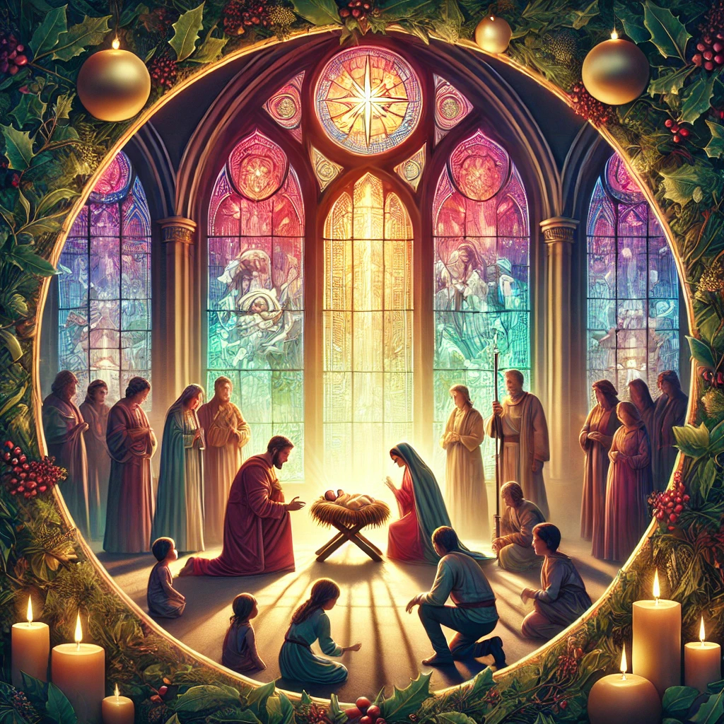

Christmas Eve

December 24, 2024

7:00 PM

Pre-service music

*Breath of Heaven,* Wendy West

*The Gift,* Tom Messmore

*A Cradle Carol,* Sinamar Respicio

*Sleep, Holy Child,* Paula Jameson

Announcements

Trinity Chimes

Prelude *On This Day, Earth Shall Ring!*

Phil Lehenbauer

*  Call To Worship

One: Who is that knocking at the door?

All: Mary and Joseph seeking shelter, looking for a place to

stay.

One: Who is that singing in the sky?

All: Angels proclaiming the news of a whole new day!

One: Who is that crying out in the wilderness?

All: God’s prophet calling for us to prepare the way.

One: Who is that knocking at the door?

All: Christ, born anew! Will we make room for love today?

*  Opening Carol 250 *Once in Royal*

*David's City* IRBY

1. Once in royal David's city  
stood a lowly cattle shed,  
where a mother laid her baby  
in a manger for his bed;  
Mary, loving mother mild,  
Jesus Christ, her little child.  
  
2. He came down to earth from heaven  
who is God and Lord of all,  
and his shelter was a stable,  
and his cradle was a stall.  
With the poor, the scorned, the lowly  
lived on earth our Savior holy.  
  
3. Jesus is our childhood's pattern;  
day by day, like us he grew;  
he was little, weak, and helpless,  
tears and smiles like us he knew;  
and he feeleth for our sadness,  
and he shareth in our gladness.  
4. And our eyes at last shall see him,  
through his own redeeming love;  
for that child so dear and gentle  
is our Lord in heaven above;  
and he leads his children on  
to the place where he is gone.

First Reading Titus 2:11-14

Grace Has Appeared

Reflection

Touching Grace – Glory Alleluia

**Anthem**  *Come, Thou Long-Expected Jesus* arr. D. Forest

The Chancel Choir

Lighting The First Candle

Reader 1: Hope, that light which calls us to the journey. The journey of life, of faith.

Reader 2: Hope – God’s grace that carries us through all things – is placed into our hearts this night as it was born into Mary’s arms long ago. We light this first Candle of Advent and name it Hope.

All: Glory, Alleluia.

Second Reading Isaiah 9:2-7

And He Shall Be Called

Reflection Name Above All Names

Carol 238 *Angels We Have Heard on High*    GLORIA

1. Angels we have heard on high

sweetly singing o'er the plains,

and the mountains in reply

echoing their joyous strains.

Refrain:

Gloria, gloria, gloria, gloria,

in excelsis Deo!

Gloria, gloria, gloria, gloria,

in excelsis Deo!

2. Shepherds, why this jubilee?

Why your joyous strains prolong?

What the gladsome tidings be

which inspire your heavenly song?

(Refrain)

3. Come to Bethlehem and see

Christ whose birth the angels sing,

come, adore on bended knee,

Christ the Lord, the newborn King.

(Refrain)

4. See him in a manger laid,

whom the choirs of angels praise,

Mary, Joseph, lend your aid,

while our hearts in love we raise.

(Refrain)

Lighting The Second Candle

One: Peace, everlasting to everlasting is born within us each, and it lives waiting to be named, to be turned into action, to flame to life just as a candle sparks to burning. We light this second candle and

name it Peace, remembering that we are children of the Prince of

Peace.

Third Reading Luke 2:1-7

No Room

Reflection A New Kind of Room

Carol 217 *Away in a Manger*

AWAY IN A MANGER

1. Away in a manger, no crib for a bed,  
the little Lord Jesus laid down his sweet head. The stars in the sky looked down where he lay, the little Lord Jesus, asleep on the hay.  
  
2. The cattle are lowing, the baby awakes, but little Lord Jesus, no crying he makes; I love thee, Lord Jesus, look down from the sky and stay by my cradle till morning is nigh.  
  
3. Be near me, Lord Jesus, I ask thee to stay close by me forever, and love me, I pray; bless all the dear children in thy tender care, and fit us for heaven to live with thee there.

Lighting The Third Candle

One: Joy is messy and unpredictable, light between clouds, the laughter of a child, an unexpected call or message. Joy makes every room it enters new, and every space adequate. We light this third candle and name it Joy knowing that it will require from us a new kind of room.

Fourth Reading Luke 2:8-20

Climb Ev’ry Mountain

Reflection Till You Find Your Dream

Carol 240 *Hark! the Herald Angels Sing*

MENDELSSOHN

1. Hark! the herald angels sing,  
"Glory to the new born King,  
peace on earth, and mercy mild,  
God and sinners reconciled!"  
Joyful, all ye nations rise,  
join the triumph of the skies;  
with th' angelic host proclaim,  
"Christ is born in Bethlehem!"

Hark! the herald angels sing,  
 “Glory to the new born King!"

2. Christ, by highest heaven adored;  
Christ, the everlasting Lord;  
late in time behold him come,  
offspring of a virgin's womb.  
Veiled in flesh the Godhead see;  
hail th' incarnate Deity,  
pleased with us in flesh to dwell,  
Jesus, our Emmanuel.  
Hark! the herald angels sing,  
"Glory to the new born King!"  
  
3. Hail the heaven-born Prince of Peace! Hail the Sun of Righteousness!  
Light and life to all he brings,  
risen with healing in his wings.  
Mild he lays his glory by,  
born that we no more may die,  
born to raise us from the earth,  
born to give us second birth.  
Hark! the herald angels sing,  
"Glory to the new born King!"

Lighting The Fourth Candle

One: Love, the dream of God, a world different and yet exactly our

own. We light this final candle standing on the edge of wonder, holding our breath, here we are, this is it, God’s dream incarnate among us, entrusted to us, placed into our hands, and now that we have found it, what will we do?

Invitation to Offering

**Offertory** *All Through the Silent Night*   arr. J. Raney

        The Christ Church Ringers

         Susan Schild, piano

Doxology *Let There Be Peace on Earth*

WORLD PEACE

Let there be peace on earth, and let it begin with me; Let there be peace on earth, the peace that was meant to be.

With God our creator, children all are we.

Let us walk with each other in perfect harmony. Let peace begin with me; let this be the moment now.

With every step I take, let this be my solemn vow: to take each moment

and live each moment in peace eternally. Let there be peace on earth, and let it begin with me

**\*Lighting the Christ Candle** John 1:1-5, 14

One: In the beginning was the Word, and the Word was with God, and the Word was God. **2**He was in the beginning with God. **3**All things came into being through him, and without him not one thing came into being. What has come into being **4**in him was life,[[a](https://www.biblegateway.com/passage/?search=John+1&version=NRSVUE#fen-NRSVUE-26039a)] and the life was the light of all people. **5**The light shines in the darkness, and the darkness did not overtake it.14 And the Word became flesh and lived among us, and we have seen his glory, the glory as of a father’s only son,full of grace and truth.

**All: Behold: God’s light shines in the darkness and we carry it into the world!**

**\*Special Music** *Prelude on Stille Nacht*

arr. D. Wagner

Christ Church Ringers

**\*Carol** 239*Silent Night*

STILLE NACHT

1. Silent night, holy night,  
all is calm, all is bright  
round yon virgin  
mother and child.  
Holy infant, so tender and mild,  
sleep in heavenly peace,  
sleep in heavenly peace.  
  
2. Silent night, holy night,  
shepherds quake at the sight;  
glories stream from heaven afar,  
heavenly hosts sing Alleluia!  
Christ the Savior is born,  
Christ the Savior is born!  
  
3. Silent night, holy night,  
Son of God, love's pure light;  
radiant beams from thy holy face  
with the dawn of redeeming grace,  
Jesus, Lord, at thy birth,  
Jesus, Lord, at thy birth.  
  
4. Silent night, holy night,  
wondrous star, lend thy light;  
with the angels let us sing,  
Alleluia to our King;  
Christ the Savior is born,  
Christ the Savior is born!

**\*Benediction**  246*Joy to the World*

ANTIOCH

1. Joy to the world, the Lord is come!  
Let earth receive her King;  
let every heart prepare him room,  
and heaven and nature sing,  
and heaven and nature sing,  
and heaven, and heaven, and nature sing.  
  
2. Joy to the world, the Savior reigns!  
Let all their songs employ;  
while fields and floods, rocks, hills, and plains  
repeat the sounding joy,  
repeat the sounding joy,  
repeat, repeat the sounding joy.

4. He rules the world with truth and grace, and makes the nations prove  
the glories of his righteousness,  
and wonders of his love,  
and wonders of his love,  
and wonders, wonders of his love.

**Postlude** *A Joyous Christmas*

by John Leavitt

Liturgist: Ed and Jane Denham

Stephen Minister: Georgia Carmichael

Golf Cart Driver: Roger Erikson

Thank you to all the staff and volunteers who made this service possible!

ONE LICENSE A-738133 | CCLI #12393 | Perform Music #662 | CVLI #03793174

“Once in Royal David’s City”

Words: Cecil Fraces Alexander, 1848 (Lk. 2:7)

“Angels We Have Heard on High”

Words: Trad. French carol; trans. Crown of Jesus, 1862, alt. (Lk. 2:6-20)

“Away in a Manger”

Words: Sts. 1-2, 15th cent. German; trans. by Theodore Baker, 1894; st. 3 from the hymnal, 1940 (Is. 35:1-2)

“Hark! the Herald Angels Sing”

Words: Charles Wesley, 1734; alt. by George Whitefield, 1763 and others (Lk. 2:8-14)

“Silent Night, Holy Night”

Words: Joseph Mohr, 1818, alt.; sts. 1,2,3 trams/ by John F Young; st. 4 trans. anon. (Lk. 2:6-20)

“Joy to the World”

Words: Issac Watts, 1719 (Ps. 98:4-9)

If you have any questions, please call the office: 520.327.1116 or

send us an e-mail: [office@ccumtucson.org](mailto:office@ccumtucson.org).

Staff contact information (Only staff with church emails are listed)

John Neve - Bell Choir Director

[john@ccumtucson.org](mailto:john@ccumtucson.org)

Janet Tolman – Organist

janet@ccumtucson.org

Sinamar Respicio – Choir Director

[choir@ccumtucson.org](mailto:choir@ccumtucson.org)

Mary Beth Buttler – Communications

communications@ccumtucson.org

Candi Eppley – Office Administrator

[office@ccumtucson.org](mailto:office@ccumtucson.org)

Rev. Beth Rambikur

[pastor@ccumtucson.org](mailto:pastor@ccumtucson.org)