### Large Print

### Christ Church United Methodisthttp://spartafumc.org/clientimages/45879/methodist%20cross.jpg

Connect with us online at

[www.ccumtucson.org](http://www.ccumtucson.org) [www.facebook/CCUM.Tucson](http://www.facebook/CCUM.Tucson)

­­­ 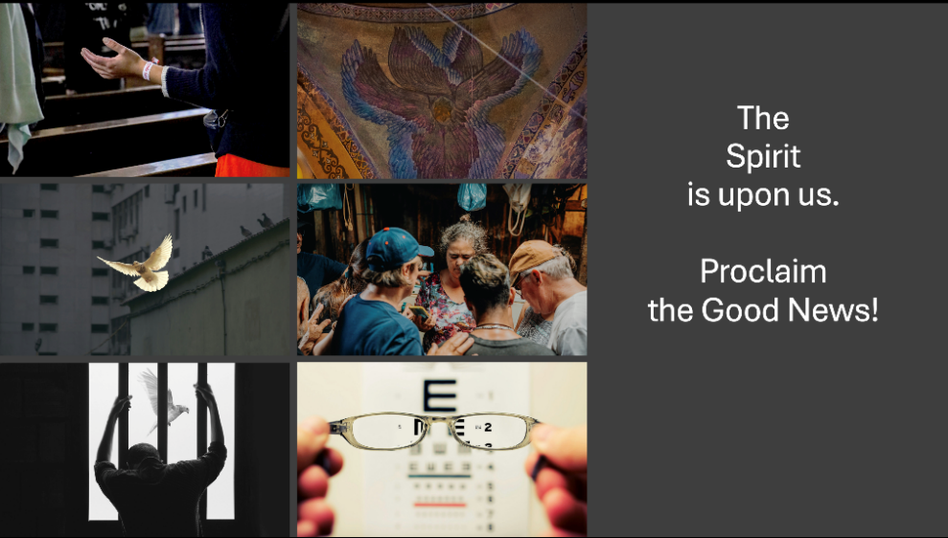

Fourth Sunday after Epiphany | February 2nd, 2025

*Please stand as you are able

**Welcome and Announcements**

Trinity Chimes

**Prelude**  *Trio No. 1* G. Merkel

*Call to Worship

One: Welcome, one and All, to the House of

the Ever-Loving God and Lord of our lives

All: We are here to Share in God’s Love.

One: Open your hearts to the Spirit in your

midst.

All: We are open and prepared to receive,

and follow your Word.

One: Rejoice and be renewed.

All: We thank you Loving Creator,

Restorer, and Sustainer,

*Hymn of Praise 529

How Firm a Foundation FOUNDATION

1. How firm a foundation,

ye saints of the Lord,

is laid for your faith

in his excellent word!

What more can he say

than to you he hath said,

to you who for refuge

to Jesus have fled?

2. "Fear not, I am with thee,

O be not dismayed,

for I am thy God

and will still give thee aid;

I'll strengthen and help thee,

and cause thee to stand

upheld by my righteous,

omnipotent hand.

3. "When through the deep waters

I call thee to go,

the rivers of woe

shall not thee overflow;

for I will be with thee,

thy troubles to bless,

and sanctify to thee,

thy deepest distress.

5. "The soul that on Jesus

still leans for repose,

I will not, I will not desert to its foes;

that soul, though all hell

should endeavor to shake,

I'll never, no, never, no, never forsake."

Opening Prayer

ALL: Lord we live like those in the Synagogue of Jesus’ home town of Nazareth. We find ourselves having limited horizons, especially as it concerns the breadth of care and concern you have for all of the world. We come here today hoping and praying for the movement of Your Spirit within us, opening us to the Active Vision and Purpose you have for us, Your Church, in transforming the World in Love.

Amen

**Scripture Reading** Jeremiah 1:4-10 (Responsive)

ONE: The LORD said: Jeremiah, I am your

Creator, and before you were born, I chose you to speak for me to the nations.

**ALL “I replied, “I'm not a good speaker,**

**LORD, and I'm too young.”**

ONE: “Don’t say you're too young,” the

LORD answered. “If I tell you to go and speak to someone, then go! And when I tell you what to say, don't leave out a word! I promise to be with you and keep you safe, so don't be afraid.”

**ALL: The LORD reached out his hand,**

**then he touched my mouth and said, “I am giving you the words to say, and I am sending you with authority to speak to the nations for me. You will tell them of doom and destruction, and of rising and rebuilding again.”**

**Children’s Moment**

*All Children are invited to come up to the front, when we finish they are invited to Sunday School.*

Music of Preparation

*The One* Craig Courtney

The Chancel Choir

Gospel Reading Luke 4:21-30 CEV

(Contemporary English Version)

21Then Jesus said to them, “What you have just heard me read has come true today.”

22All the people started talking about Jesus and were amazed at the wonderful things he said. They kept on asking, “Isn't he Joseph's son?” 23Jesus answered: You will certainly want to tell me this saying, “Doctor, first make yourself well.” You will tell me to do the same things here in my own hometown that you heard I did in Capernaum. 24But you can be sure that no prophets are liked by the people of their own hometown. 25Once during the time of Elijah there was no rain for three and a half years, and people everywhere were starving. There were many widows in Israel, 26but Elijah was sent only to a widow in the town of Zarephath near the city of Sidon. 27During the time of the prophet Elisha, many men in Israel had leprosy. But no one was healed, except Naaman who lived in Syria.

28When the people in the synagogue heard Jesus say this, they became so angry 29that they got up and threw him out of town. They dragged him to the edge of the cliff on which the town was built, because they wanted to throw him down from there. 30But Jesus slipped through the crowd and got away.

Sermon “How Expansive is your God?”

Music of Response

*Passing of the Peace

Invitation to Offering

Offertory *An Offering*

Dan Forrest

Sinamar Respicio, solo

*Doxology

LASST UNS ERFREUEN

Praise God, from whom all blessings flow;

Praise God, all creatures here below.

Alleluia! Alleluia!

Praise God, the source of all our gifts!

Praise Jesus Christ, whose power uplifts!

Praise the Spirit, Holy Spirit,

Alleluia! Alleluia! Alleluia!

Offertory Prayer

**\*Holy Communion**

The Lord be with you.

**And also with you.**

Lift up your hearts.

**We lift them up to the Lord.**

Let us give thanks to the Lord our God.

**It is right to give our thanks and praise.**

Blessed are you, our Alpha and our Omega,

whose strong and loving arms encompass the universe, for with your eternal Word and Holy Spirit you are forever one God.

Through your Word you created all things and called them good, and in you we live and move and have our being. When we fell into sin, you did not desert us.

You made covenant with your people Israel

and spoke through prophets and teachers.

In Jesus Christ your Word became flesh and dwelt among us, full of grace and truth.

And so, with your people on earth and all the company of heaven we praise your name and join their unending hymn:

**Holy, holy, holy Lord, God of power and might, heaven and earth are full of your glory. Hosanna in the highest. Blessed is he who comes in the name of the Lord. Hosanna in the highest.**

Holy are you, and blessed is Jesus Christ, who called you Abba, Father. As a mother tenderly gathers her children, you embraced a people as your own and filled them with a longing for a peace that would last and for a justice that would never fail. In Jesus’ suffering and death you took upon yourself our sin and death and destroyed their power for ever. You raised from the dead this same Jesus, who now reigns with you in glory, and poured upon us your Holy Spirit, making us the people of your new covenant.

On the night before meeting with death, Jesus took bread, gave thanks to you, broke the bread, gave it to the disciples, and said: “Take, eat; this is my body which is given for you. Do this in remembrance of me.”

When the supper was over Jesus took the cup, gave thanks to you, gave it to the disciples, and said: “Drink from this, all of you; this is my blood of the new covenant, poured out for you and for many for the forgiveness of sins. Do this, as often as you drink it, in remembrance of me”

And so, in remembrance of these your mighty acts in Jesus Christ, we offer ourselves in praise and thanksgiving as a holy and living sacrifice, in union with Christ’s offering for us, as we proclaim the mystery of faith.

**Christ has died; Christ is risen; Christ will come again.**

Pour out your Holy Spirit on us gathered here, and on these gifts, that in the breaking of this bread and the drinking of this wine we may know the presence of the living Christ and be renewed as the body of Christ for the world, redeemed by Christ’s blood.

As the grain and grapes, once dispersed in the fields, are now united on this table in bread and wine, so may we and all your people be gathered from every time and place into the unity of your eternal household and feast at your table for ever.

Through Christ, with Christ, in Christ, in the unity of the Holy Spirit, all honor and glory is yours, almighty God, now and forever.

**Amen**.

**Communion Hymn** 632

Draw Us in the Spirit's Tether UNION SEMINARY

1. Draw us in the Spirit's tether,

for when humbly in thy name,

two or three are met together,

thou art in the midst of them.

Alleluia! Alleluia! Touch we now

thy garment's hem.

2. As disciples used to gather

in the name of Christ to sup,

then with thanks to God the Father

break the bread and bless the cup.

Alleluia! Alleluia! So now bind

our friendship up.

3. All our meals and all our living

make as sacraments of thee,

that by caring, helping, giving,

we may true disciples be.

Alleluia! Alleluia!

We will serve thee faithfully.

The Lord’s Prayer:

Our Father, who art in heaven, hallowed be thy name. Thy kingdom come, thy will be done, on earth as it is in heaven. Give us this day our daily bread and forgive us our trespasses as we forgive those who trespass against us, and lead us not into temptation, but deliver us from evil, for thine is the kingdom and the power and the glory forever. Amen

**\*Sending Hymn** 2158 Just a Closer Walk with Thee

CLOSER WALK

1. I am weak, but thou art strong;

Jesus, keep me from all wrong;

I'll be satisfied as long

as I walk, let me walk close to thee.

**Refrain**

Just a closer walk with thee,

grant it, Jesus, is my plea,

daily walking close to thee:

Let it be, dear Lord, let it be.

2. Through this world of toil and snares,

if I falter, Lord, who cares?

Who with me my burden shares?

None but thee, dear Lord, none but thee.

**Refrain**

Benediction

May the Lord bless you and keep you. May the Lord make his face to shine upon you and be gracious unto you. May the Lord lift up his countenance upon you and give you peace, Amen!

Postlude *Grand Chorus* Theodore Dubois

Thank you to all of the volunteers and staff who made this service possible!

Liturgist: Iris Washburn

Stephen Minister: Cat Reinke

Golf Cart Drive: John Tejada

ONE LICENSE A-738133 | CCLI #12393 | Perform Music #662 | CVLI #03793174

“How Firm a Foundation”

Words: “K” in Rippon’s Selection of Hymns, 1787 (2 Tim. 2:19; Heb. 13:5;; Is. 43:1-2)

“Just a Closer Walk with Thee”

Words: Anon. (James 4:8)

If you have any questions, please call the office: 520.327.1116 or

send us an e-mail: office@ccumtucson.org.

Staff contact information (Only staff with church emails are listed)

John Neve - Bell Choir Director

[john@ccumtucson.org](mailto:john@ccumtucson.org)

Janet Tolman – Organist

janet@ccumtucson.org

Sinamar Respicio – Choir Director

[choir@ccumtucson.org](mailto:choir@ccumtucson.org)

Mary Beth Buttler – Communications

communications@ccumtucson.org

Candi Eppley – Office Administrator

[office@ccumtucson.org](mailto:office@ccumtucson.org)

Rev. Beth Rambikur

[pastor@ccumtucson.org](mailto:pastor@ccumtucson.org)