### Large Print

### Christ Church United Methodisthttp://spartafumc.org/clientimages/45879/methodist%20cross.jpg

Connect with us online at

[www.ccumtucson.org](http://www.ccumtucson.org) [www.facebook/CCUM.Tucson](http://www.facebook/CCUM.Tucson)

­­­ 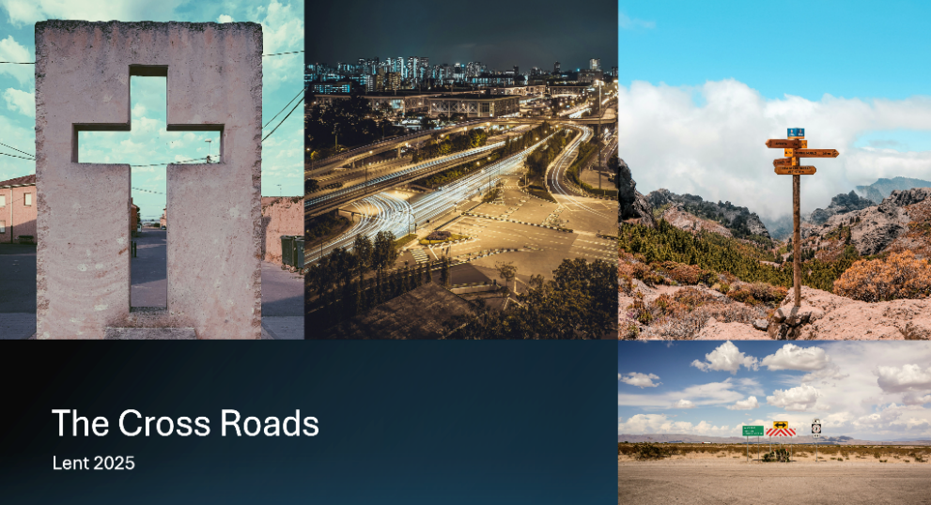

First Sunday of Lent | March 9th 2025

*Please stand as you are able

**Welcome and Announcements**

Trinity Chimes

**Prelude**  *Share His Love*

Reynolds/Sykes

Kathy Ferguson, piano

Janet Tolman, organ

*Call to Worship

One: We gather at the cross roads of blessing and woe,  
**All:** **Seeking the way that leads to life.**

One: Jesus turns the world upside down, inside out  
**All:** **Let this be a place of finding the courage of living this way.**

\***Hymn of Praise** 60  *I'll Praise My Maker While I've Breath* OLD 113

1. I’ll praise my Maker while I’ve breath;

and when my voice is lost in death,

praise shall employ my nobler powers.

My days of praise shall ne’er be past,

while life, and thought, and being last,

or immortality endures.

2. Happy are they whose hopes rely on Israel’s God, who made the sky and earth and seas, with all their train;

whose truth forever stands secure,

who saves th’ oppressed and feeds the poor,

for none shall find God’s promise vain.

3. The Lord pours eye-sight on the blind; the Lord supports the fainting mind and sends the laboring conscience peace. God helps the stranger in distress,

the widow and the fatherless,

and grants the prisoner sweet release.

4. I’ll praise my God who lends me breath;

and when my voice is lost in death,

praise shall employ my nobler powers.

My days of praise shall ne’er be past,

while life and thought, and being last,

or immortality endures.

Opening Prayer

**God of blessing and challenge, You stand at the crossroads and call us forward. You lift the lowly, fill the hungry, bless the poor. Open our hearts to Your wisdom, our hands to Your generosity, our lives to Your kingdom where the Spirit moves, amen.**

Scripture Reading Psalm 27:1-5

The Lord is my light and my salvation;  
    whom shall I fear?  
**The Lord is the stronghold[**[**a**](https://www.biblegateway.com/passage/?search=Psalm%2027%3A1-5&version=NRSVUE#fen-NRSVUE-14287a)**] of my life;  
    of whom shall I be afraid?**

When evildoers assail me  
    to devour my flesh—  
my adversaries and foes—  
    they shall stumble and fall.

**Though an army encamp against me,  
    my heart shall not fear;  
though war rise up against me,  
    yet I will be confident.**

One thing I asked of the Lord;  
    this I seek:  
**to live in the house of the Lord  
    all the days of my life,**to behold the beauty of the Lord,  
    and to inquire in his temple.

**For he will hide me in his shelter  
    in the day of trouble;  
he will conceal me under the cover of his tent;  
    he will set me high on a rock.**

Music of Preparation *My Savior's Love*

David Schwoebel

The Chancel Choir

**Gospel Reading Luke 6:17-25**

**Sermon** The cross roads of blessing and woe

Pastor Beth

Musical Response

Prayers of the People

Prayer of Confession

Holy and merciful God, we confess that we are drawn to the world’s idea of blessing – comfort, security, and success. We avoid the places of discomfort, the people in need, the hard choices that require sacrifice. Yet You tell us that true blessing is found in the way of Christ- where the poor are lifted up, the hungry are filled and the sorrowful find joy. Forgive us for choosing the easy way , set our feet upon your path, knowing that Your blessing sustains us, even in the hardest moments. Amen.

Pastor: Hear the Good News, Christ is among us renewing us for life with love. In the name of Christ, you are forgiven!

People: In the name of Christ you are forgiven!

All: Glory to God, Amen.

Lord’s Prayer

Our Father, who art in heaven, hallowed be thy name. Thy kingdom come, thy will be done, on earth as it is in heaven. Give us this day our daily bread and forgive us our trespasses as we forgive those who trespass against us, and lead

us not into temptation, but deliver us from evil, for thine is the

kingdom and the power and the glory forever. Amen.

*Passing of the Peace

Invitation to Offering

Offertory *Lord, Here Am I* Beck/Sykes

Kathy Ferguson, piano

Janet Tolman, organ

*Doxology *A Lenten Doxology*

OLD 100TH

Praise God throughout these forty days.

Praise Christ, our Lord, whom God did raise. And praise the Spirit who imparts

God’s love in Christ into our hearts. Amen

*Offertory Prayer

**\*Sending** 421 *Make Me a Captive, Lord*   DIADEMATA

1. Make me a captive, Lord, and then I shall be free. Force me to render up my sword, and I shall conqueror be. I sink in life's alarms when by myself I stand; imprison me within thine arms, and strong shall be my hand.

2. My heart is weak and poor until it master find; it has no spring of action sure, it varies with the wind. It cannot freely move till thou hast wrought its chain; enslave it with thy matchless love, and deathless it shall reign.

3. My power is faint and low till I have learned to serve; it lacks the needed fire to glow, it lacks the breeze to nerve.

It cannot drive the world until itself be driven; its flag can only be unfurled

when thou shalt breathe from heaven.

4. My will is not my own till thou hast made it thine; if it would reach a monarch's throne, it must its crown resign. It only stands unbent amid the clashing strife,

when on thy bosom it has leant, and found in thee its life.

*Benediction

Go now, travelers on the road with Christ!

May the path rise up to meet our feet,

May wisdom keep us from retreat.

May love’s compass point the way,

And hope sustain us day by day.

Along the cross roads, let the blessings we find Remind us of God’s promise to be with us always. Amen

Postlude *The Promised Land*

arr. Gayden C. Sykes

Kathy Ferguson, piano:

Janet Tolman, organ

Thank you to all of the volunteers and staff who made this service possible!

Liturgist: Paula Jameson

Stephen Minister: Michael Edwards

Golf Cart Drive: Tom Haslag

ONE LICENSE A-738133 | CCLI #12393 | Perform Music #662 | CVLI #03793174

“Love Devine, All Loves Excelling”

Words: Charles Wesley, 1747

“God Will Take Care of You”

Words: Civilla D Martin, 1904

“Make Me a Channel of Your Peace”

Words: Prayer of St Francis; adapt. By Sebastian Temple (Matt. 6:12-15)

If you have any questions, please call the office: 520.327.1116 or

send us an e-mail: office@ccumtucson.org.

Staff contact information (Only staff with church emails are listed)

John Neve - Bell Choir Director

[john@ccumtucson.org](mailto:john@ccumtucson.org)

Janet Tolman – Organist

janet@ccumtucson.org

Sinamar Respicio – Choir Director

[choir@ccumtucson.org](mailto:choir@ccumtucson.org)

Mary Beth Buttler – Communications

communications@ccumtucson.org

Candi Eppley – Office Administrator

[office@ccumtucson.org](mailto:office@ccumtucson.org)

Rev. Beth Rambikur

[pastor@ccumtucson.org](mailto:pastor@ccumtucson.org)